St. Margaret’s Church

Draycott-le-Moors

Trustees Annual Report

January to December 2020

APPROVED
BY St MARGARET’S PAROCHIAL CHURCH COUNCIL
PRIOR TO THE APCM MEETING SCHEDULED FOR 25TH MAY 2021 AT 7.30pm IN THE CHURCH.

Contents:

1. St Margaret’s PCC

2. Electoral roll

3. Proceedings of PCC

4. Proceedings of the Parish
Including:
- Children’s and Youth discipleship Enabler Report
- Bell Ringers Report
- Church Flowers/Cleaning
- Rector’s Report
- Community support in Draycott, 2020 - notes by K. Bradshaw.

5. Financial Statements of the PCC
Including:
- Statement of Financial Activities
- Analysis of receipts and payments
- Balance sheet
- Gift Aid report

6. Fabric Report

7. Church Hall Report and Accounts

8. Deanery Synod Report

9. St Margaret’s Bell Ringers annual statement of accounts

St Margaret’s PCC
Aims and Purposes.
St Margaret’s Parochial Church Council (PCC) has the responsibility of cooperating with the Rector, the Revd. Jonathan Roberts, in promoting in the parish the whole mission of the church, and specifically fulfilling the PCC’s Mission Statement – Glorifying God; Following Jesus; Growing Disciples; Transforming Communities’. This is undertaken in various ways and in cooperation with St Peter’s Forsbrook, who share the same Ministry Leadership Team (as an independent legal parish, St Peter’s is not covered by this report).
The PCC is specifically responsible for the maintenance of the parish church of St Margaret’s.

Administrative Details.
St Margaret’s Parish Church is located in the ecclesiastical parish of Draycott-le-Moors, covering the communities of Draycott-le-Moors, Cresswell and Totmonslow.
Location: Church Lane, Draycott-le-Moors, Stoke-on-Trent ST11 9AG
Postal Address is c/o The Revd. Jonathan Roberts
The Rectory, Cheadle Road, Blythe Bridge, Staffordshire ST11 9PW
Tel: 01782 437600 Email: revdjphroberts@gmail.com
Web site: stmargaretsdraycott.org

Bank: NatWest, Longton, Staffs.

Composition of St Margaret’s Parochial Church Council 2020:
Ex-officio Members:
Rector: Revd. Jonathan Roberts Chair of the PCC
Curate: Revd. S. Crossley
Children’s & Youth Discipleship Enabler: Mrs C. Thompson
Licensed Readers: Mrs Kate Bradshaw Deanery Synod representative 2020/2023 Mr Clive Lilley
Mr Graham Stokes
Lay Pastoral Worker: Leigh Silcock
Church Wardens: Mr A. J. Fletcher
Mrs J. H. Meller and Deanery Synod rep. 2020/2023
Deanery Synod rep 2020/2023: Mr D. Meller and PCC Secretary,

Elected Members:

J. Moore 2017-2020
S. Hughes 2018-2021
M. Edwards 2019-2021 Vice Chair, Treasurer
M. Pointon 2018-2021
P. Clarke 2019-2022
S. Edwards 2019-2022
W. Mears 2020-2023
J. Thompson 2020-2023
C. Wibberley 2020-2023

Members of the PCC are elected in accordance with Canon Law at the APCM
PCC Constitution.
The Parochial Church Council is a corporate body established by the Church of England and the PCC operates under the Parochial Church Council Measure. The PCC is excepted by order from registering with the Charity Commission.
Objectives and Activities.
The PCC is committed to enabling as many people as possible to worship in our parish church and to become a part of the community of St Margaret’s. This is undertaken according to the doctrines and structures of the Church of England.
The PCC maintains an overview of worship, the care of the church building and mission. Our worship is led by a Ministry Leadership Team with two organists who cover the playing of music in the services.
Mission and ministry with children, young people and their families within the benefice is led by a part-time Children’s and Youth Leader, whose time is shared with the local Methodist church.
The PCC has complied with the duty under section 5 of the Safeguarding and Clergy Discipline Measure 2016 (duty to have regard to House of Bishops’ guidance on safeguarding children and vulnerable adults).
Mission
Our (benefice) Mission Statement reminds us that it is not the church of God which has a mission in the world, but the God of mission who has a church in the world.
As two churches, we are united around the cross of Jesus Christ, which is why this symbol is at the centre. Our mission can be summarised in four statements:
Glorifying God is the aim of every Christian (1 Corinthians 10:31). We seek to bring him the glory due to his name through our WORSHIP – both corporately when we gather together (Revelation 4:9-11) and in our individual lives (Romans 12:1-2).
Following Jesus is the Christian life. Jesus called people to follow him unreservedly when he lived on earth, and today he continues to invite us with the same call – ‘follow me’ (Matthew 4:19). Responding to his call is the life of DISCIPLESHIP which is both costly and rewarding (Mark 8:34-35).
Growing Disciples is at the heart of the reason for the church’s existence. In his final words to the disciples before his ascension, Jesus commanded his followers to make disciples (Matthew 28: 19-20). It has always been God’s intention that his people should draw others to himself and EVANGELISM and DISCIPLESHIP should be a normal and expected part of our life corporately and individually. Spiritual growth in people, however, is God’s work (1 Corinthians 3:6-8) and he graciously invites us into that process.
Transforming Communities is the outcome for which we hope and PRAY as we seek to be ambassadors for Christ in the communities to which we belong. Jesus reminds us that we, as his people, are to be salt and light - agents of transformation – in places where there is moral decay and spiritual darkness (Matthew 5:13-16). We PRAY for the coming of God’s kingdom on earth as it is in heaven.

Achievements and Performance.
Usually, the PCC reviews and prepares a Mission Action Plan (MAP) for the year. The Covid-19 pandemic has made 2020 a very different year and any ‘plans’ which were in place and due to be reviewed and re-formulated were pretty much abandoned because of the need to react to the changing and unexpected course of events. The Rector’s report highlights some of the immediate actions which were necessary and responded to in a way that sought to be both practical and missional. Some of the other reports will highlight other aspects of the way in which our church has continued to operate.
The PCC has endeavoured to continue to fulfil its responsibilities this year via email. Some decisions have had to be made by the Rector and Wardens or Standing committee at short notice.

Key areas of mission and ministry have included:
- A mixed economy of online and ‘in building’ worship
- Online Bible study groups
- A growing network of pastoral care and electronic communication
- Funeral ministry

Some of our longstanding groups and ministries have not been able to function during most of the year which has been difficult for many.
We enter 2021 with many questions and challenges. The PCC and whole church community have an opportunity to consider afresh what it means to be ‘church’ in 2021 in a (post-) pandemic context. I am sure that God has many opportunities for us which will require courage and discernment as we seek to love him and make his love known.

2. Electoral Roll Officer’s Report January to December 2020.
The number of people on the Electoral Roll stands at 52.
J. Moore.
ERO.
3. Report on the year’s proceedings of St. Margaret’s PCC January to December 2020.
The first meeting in 2020 of St Margaret’s PCC took place in the Church Hall on 20th January.
Reference was made to the repairs to the surface of Church Lane, carried out by the contractor,
St Modwen. Revd Roberts expressed his thanks to all those who were involved in bringing the repairs about and particularly the involvement of J. Moore.
St Margaret’s safeguarding policy had been updated and copies “Revised 20th January 2020” had been distributed to PCC members There was a copy in the Vestry, and a copy was posted on St Margaret’s website.
The offer from Draycott Women’s Institute, to replace the broken bench outside church gate was accepted.
M. Pointon had arranged to have a risk assessment carried out in the bell tower. The report was awaited.
Revd Roberts confirmed all members on the parochial electoral roll had been invited to attend the proposed Everybody Welcome course.
Arrangements for the 2020 Summer Fayre are proceeding.
Future fundraising events were proposed including a tabletop sale, and a gospel choir concert.
Discussions took place regarding the absence of rules regarding the interment of remains in the cremated remains area of the churchyard. It was agreed that the cremated remains area would be subject to the existing rules governing burials in the churchyard.

The next meeting was scheduled for 31st March 2020, in the Church Hall. Due to the Coronavirus pandemic the next meeting was cancelled.

The PCC did not meet again until 5th October 2020.
Access to the building during lockdown was dictated by the various Government rules and CE guidance. PCC members and those on the electoral roll were kept informed by email, letter and phone calls. From the start of lockdown St Margaret’s was closed. The Benefice had an online service on Facebook at 10.00 am on Sunday mornings.
As regulations eased in July, services were allowed in church and at St Margaret’s they took place at 4.00 pm on Sundays, alternating between Holy Communion and Evening Prayer.
From 4th October the starting times were altered to 10.00 am.
With the closure of the building donations could not be made via the collection plate. Church members had been informed of various ways to continue their giving through online donations, standing orders, and money transfers.
The Summer Fayre committee had taken the decision not to hold the event in 2020. The tabletop sale and the Gospel Choir events were also cancelled.
The Standing Committee had taken the decision to temporarily suspend payments of the Parish Share. Revd Roberts expressed his thanks to Mr A. Bird for cutting the grass in the lower churchyard. The draft 2019 TAR had been circulated to all PCC members prior to the meeting. At the request of
M. Edwards, Totmanslow had been added to the ‘Administrative Details’ section. There were no further questions, clarifications or corrections required and the 2019 Trustees Annual Report was accepted by all present.
Following discussion, Revd Roberts, K. Bradshaw and J. Meller agreed to investigate the possibility of holding the Remembrance Service on Sunday 8th November 2020. This could take place outside. Draycott WI, and Draycott Moor College may be invited to have some input.
K. Bradshaw suggested that Harvest Festival should be marked by an appeal from the pulpit for tinned food donations to be collected at church and passed to a local food bank.
Discussion on Christmas services was deferred.
The Treasurer’s report had been circulated to all PCC members prior to the meeting. Discussion took place regarding the report, our recent Gift Aid claim, the outstanding parish
share amount and the general state of the Diocese finances. It was agreed to pay £1000.00 off the parish share.
Lockdown has caused the suspension of the magazine, and R. Parish, B Parish and M. Pritchard had stepped down from their roles. If we wish to continue publishing, we need to create a new team. T. Fletcher said that he thought the magazine was a good project and an opportunity to communicate beyond the walls. It was agreed by all those present that St Margaret’s church should have a separate website from St Peter’s. Revd Crossley stated the costs and two members of the PCC offered to meet the cost. The offer was accepted by the Rector on behalf of the PCC.
Revd Roberts explained that within the Covid-19 rules it might be possible to hold outdoor activities for children. A new Tiddlers Group would like to use the church hall grounds, with access to the indoor toilets. Subject to following the Covid-19 rules it was agreed that the group could have use of the grounds and toilet. The flagpole had been damaged. Revd Roberts expressed the PCC’s thanks to Mr J. Clarke for carrying out repairs, and all the other work he does for St Margaret’s.
Revd Roberts thanked everyone for their prayers and help. The building might be closed but we are still in business.
The next meeting was the AVM followed by the APCM on Monday 19th October 2020 in the Church.
PCC meeting 19th October 2020.
Annual Vestry Meeting (AVM).
The meeting took place in the Church and conformed with the social distancing rules.
Both J. Meller and A. Fletcher had agreed to stand as wardens and in the absence of any other candidates were elected un-opposed for a further period of 12 months.

Annual Parochial Church Meeting (APCM).
The 2019 Trustees Annual Report, approved at the PCC meeting on 5th October, had been circulated prior to the meeting, and there were no questions about its content.
Following the procedures in the Church Representation Rules (2020), K. Bradshaw, D. Meller and J. Meller were duly elected as Deanery Synod members for a three-year period.
There were four positions open on the St Margaret’s PCC and W. Mears and C. Wibberley agreed to their nomination again, and J. Thompson also agreed to be nominated. All three were accepted for a three-year period.
Following discussion, it was agreed to increase the number of laity places on the PCC from nine to eleven. This will take effect from the 2021 APCM.
M. Corbishley was appointed our independent accounts examiner for 2020/21.
No date was set for a future meeting.

D. Meller.
4. Report on the year’s proceedings of St. Margaret’s Parish January to December 2020.
- Children’s and Youth discipleship Enabler Report

Youth & Children’s Discipleship Enabler Report
In wondering where to start when looking back at 2020, I was reminded of what I wrote at the end of the 2019 report:
“As we enter into 2020 our main focus is on relationships – with our peers, between adults and children, and between us all and God. Please continue to pray that we all grow in our relationship with God and know His presence with us as we serve and grow together.”

Who could’ve imagined 2020 would be so different to the year before - but God did. I remember being so sure that relationships were going to be key, and the reality is that we are where we are today because of the relationships we’ve been investing in for many years and those nurtured during a very different time. I’m reminded time and again that Jesus died for people rather than buildings and programmes and although this year has been different and difficult, we’ve continued to develop relationships with our children, young people and their families. There has been much to mourn, particularly the lack of face-to-face youth groups and suspension of public worship, but also much to give thanks for. We’ve learnt that Zoom is our ‘new friend’, creating videos is much harder (and time consuming) than it looks, and doorstep deliveries are about more than delivering a bag of items. Above all, I’ve been reminded that God knows (what has been, what is now, and what is to come).

Our Friday evening groups have a healthy membership and although we loved meeting at the Methodist Church, had to move online in April following a few weeks of working out the best way forward. Numbers have been lower online, but when we returned to our building in October for a few weeks we saw many return and look forward to seeing them again in 2021. We kept in touch with messages, conversations in the street and something regularly delivered to all those that were registered. The distribution grew to include those from God Squad and x:cite as the months passed and we realised life was changing.

God Squad was a new group of young people who want to develop their Christian faith that started towards the end of 2019. We were meeting in people’s houses, which is no longer permitted, and moved online along with everything else. With everything going on, the isolation from online learning and having to stay at home, we increased to meeting fortnightly for a while and even managed to meet at St. Peter’s for a few in the Summer before restrictions were tightened again. Sadly, Emma had to suddenly return to Germany as Covid-19 began to take hold but many of the group are still enjoying meeting in whatever way we can and studying the Bible together. Please pray for this group especially as they finish Year 11 and look to their future in the coming months.

Messy Church has tried all sorts of ways to engage with the families that usually attend and help them develop their faith at home. We met together as usual in February and look forward to being able to do so again, but who can forget the wonderful online Messy Church sessions lead by Sophie and Jonathan (and Theo) on Good Friday and in June? A Messy Church craft bag was delivered to all the families we could in August, and we shared a special time outside on our Messy Church Light Night Treasure Hunt at the end of October. It was so well received I wonder if it might be something we do more. I give special thanks to and for Sophie, who took on co-ordinating Messy Church at the beginning of the year and didn’t run away screaming when everything changed. Messy Church celebrates the creativity of God and I see the outworking of that creativity in a team that is willing to find a way to keep engaging children, young people and families in discovering God together.

With the restrictions placed on public worship this year, X:cite had to change too. It was wonderful to be able to meet upstairs during the 10am service for the first few months, but for most of the rest of the year the x:cite team became Facebook stars. For 35 weeks we produced a weekly video encouraging children and their families to engage with God at home, creatively and reflectively. Special thanks go to Archie who took on editing the videos and brought an extra creative element and to Margaret who has been a creative Queen behind the scenes too. Advent saw a change of pace, and we got out and about to find the characters of the Christmas story ‘hidden’ around the area. This helps us remember that our discipleship and relationship with God is something we must invest in for ourselves – watching videos is great and can really help, but faith is best taught and shared in the home. I am always happy to help if you need some pointers or support in sharing faith at home – just get on touch!

What can I say about schools? From March, we continued to provide input into Forsbrook Primary through videos and Collective Worship where possible. Blythe Bridge High School’s Year 7 Christmas Service included readings that were pre-recorded in St. Peter’s and I’ve continued to support Springcroft through regular contact, occasional cake deliveries, and prayer. A Christmas Service and reflection were also produced and made available to Forsbrook, Springcroft and William Amory. Our ongoing relationships with local schools continue to be strong and I look forward to visitors being allowed back into school in 2021.

Our focus for 2021 is ‘thrive’ – we pray for a year in which, as children, young people, families and a community of God, we don’t just survive, but we flourish and prosper.

Jesus said, “a thief comes to steal and kill and destroy, but I came to give life – life in all its fullness.” (John 10:10)

Chrissi Thompson.

4 (b) Bell Ringers’ Report 2020.

In December 2019, M. Pointon, St Margaret’s Health and Safety representative commissioned Mr. M Robinson to carry out a risk assessment in the bell tower. The completed report was received in February 2020. Work has started on implementing the recommendations, and Mr. J. Clarke has strengthened the bottom step on the ladder leading to the upper chamber. There is a copy of the report kept in the vestry.
With the closure of all churches on 24th March 2020, due to the Coronavirus pandemic, bell ringing activities at St Margaret’s ceased. As the rules and guidance changed, one of the bell ringing team was allowed into church and the bells were rung on several occasions:
Until the nationwide practice ceased, on three consecutive Thursdays in support of the NHS
On Remembrance Day prior to the service, and to signal the end of the silence
On Armistice Day
Prior to the start of services when the 10.00 am Sunday services resumed
After the Christmas Morning service.

Writing this report in January 2021, the church has had to close again, and all services are suspended until the 31st March 2021.

4 (c) Church Flowers and Cleaning Report January to December 2020.
No flowers have been in church for the past 14 months as due to Covid19, access to the building has been restricted. All cleaning has been done by Churchwardens. We are extremely grateful to them for this.

J. Moore.

4 (d) Rector’s Report January to December 2020.
No one could have predicted the year that 2020 has been. We entered the year having heard of the effects of the coronavirus in far-off places round the world and by March we had entered the first ‘lockdown’. The coronavirus pandemic has affected every area of life for individuals and for society as a whole since then.
As a church, we began the year with a sense of seeking ’20-20’ vision and with the ‘Everybody Welcome’ course planned for Lent which we hoped would help us to identify ways of being a more accessible church in our local community. We were half-way through this when ‘lockdown’ began and it was frustrating not to be able to complete what had been started.
The immediate challenge just weeks before Easter and with church buildings closed and our magazine unable to continue was threefold: (i) to maximise communication channels with church members; (ii) identify those in our locality who were most vulnerable and might need particular care; (iii) establish an online presence for our worship. It was frustrating not to be able to have the time to deal with some these issues in a more structured and strategic way, but by God’s grace we were able to address these issues and I thank God for those who were willing and able to play their part.
I am very hesitant to mention individual names because I know there are many people who have sought to serve, help and support those in need in any ways possible. A very sincere ‘thank you’ to all those who have made phone calls and made contact with local friends and neighbours in need – especially the most vulnerable. You have been ‘the body of Christ’ in action. I would, however, like to thank a few individuals whose particular gifts and ability to fulfil certain roles made a significant difference to the challenges we faced as a church at this particular point.
It has been very difficult for the PCC to meet as face-to-face meetings have been impossible and some of our members are not able to meet virtually. As a result, the St Margaret’s Standing Committee (Wardens, Secretary and Treasurer) has needed to make some decisions in response to the changing course of the pandemic and I am grateful to them for their support in this.
I want to particularly thank Chrissi Thompson, and those who have continued to work alongside her, and how she adapted her role and the various online and ‘in-person’ ways in which we have been able to keep in contact with and, whenever possible, continue to encourage children, young people and their families in their discipleship. I also want to thank Sam Crossley for his commitment and gifts which have enabled us to produce online worship of a high quality for over 12 months now. Sam has also developed our online bible studies alongside Clive and is continuing to oversee the development of our new website. I also want to thank Sophie Roberts for sharing with me the daily challenges of life and leadership during a pandemic.
As we emerged out of different ‘lockdowns’ there were more new issues and challenges as we sought to measure risks, open up our buildings when possible, and maintain our online presence as well as seeking to offer a form of worship in our buildings which was appropriate and safe. There are various people whose contributions were so valuable, including Jane, Tony, Dave and Mary whose help in preparing our church building and hall ready for use again has been much appreciated. Jane has overseen the cleaning of church over this period; Tony has continued to act as Verger at funerals throughout the pandemic; Dave has supported both wardens in various ways (not least the up to date notices) and communication with PCC when necessary; Mary has overseen the preparation of the Church Hall which has been a challenging process.
I’m also very grateful for the team involved in supporting funeral ministry throughout what has been a particularly challenging time for bereaved families and for us as a church. My thanks to Kate Bradshaw, Clive Lilley and Sam Crossley who have shared with me in taking a large number of funerals over the year, and to Ruth Silcock and Jane and Tony for enabling the practical arrangements around holding ‘covid-safe’ funerals (as well as ‘in building’ services) to go so safely and smoothly.
As we enter 2021, we do so with a sense of both lament for what has been lost, but also thankfulness for new things that God has provided and taught us. We will need to engage (both as a local church and as part of the ‘national’ church on a deanery and diocesan level) with some big questions about the shape of our life and mission in the months and years ahead. We will need to cultivate attentiveness to the promptings of the Spirit and prayerful trust in Jesus Christ as he leads his church into the future.
Revd. Jonathan Roberts (Rector)
4 (e) Community support in Draycott, 2020 - notes by K. Bradshaw.

In March 2020 when the Covid lockdown began I was faced with thinking how can I be of use in my community when church doors had closed and I was classed as being in a vulnerable category together with a husband even more vulnerable and living behind closed doors. What could I do?

I decided to put out an appeal on Social Media and on a noticeboard outside my house to see if there were local people who would be prepared to build a team to be the helpers for those less able than themselves. Very quickly the group grew to around 40 members and I also set up a WhatsApp group for those who have phones but don't do Social Media. I liaised with Blythe Centre and with Draycott Parish Council to get a newsletter printed and distributed at all 450 properties in Draycott, Cresswell and Totmonslow. And as the weeks of lockdown went on many stories of help and random acts of kindness began to emerge. Some stories may never be told but for the first time in 20 odd years I saw neighbours being neighbours and lonely people being helped and so much kindness. As we approached the marking of VE day the chat groups wanted to put together some kind of community event and we came up with the Scarecrow Event which proved to be very successful with around 48 scarecrows - we made the local press double page spread.

Gradually as the year wore on the needs diminished but some still remain - I know of one lady who is still cooking for an old lady living alone, of others who will still fetch a prescription or a bit of shopping. This was community action at its finest and I was glad to be the organiser from behind closed doors.

Kate Bradshaw.

5, Financial statements of the PCC
Including:
- Statement of Financial Activities
- Analysis of receipts and payments
- Balance sheet.
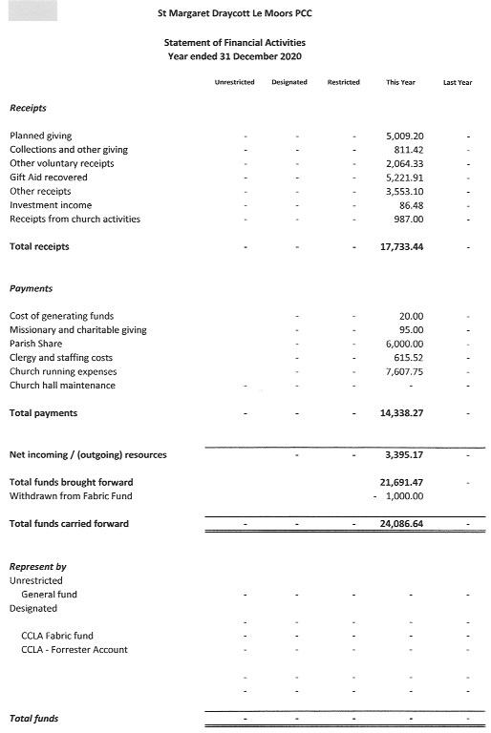
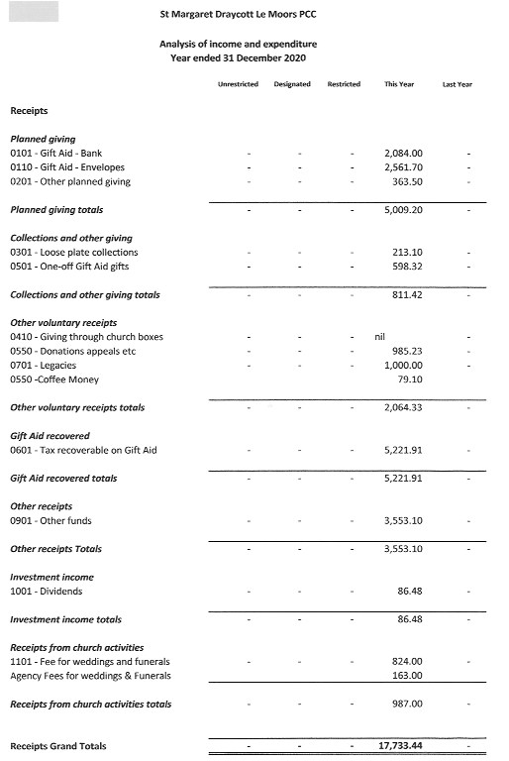
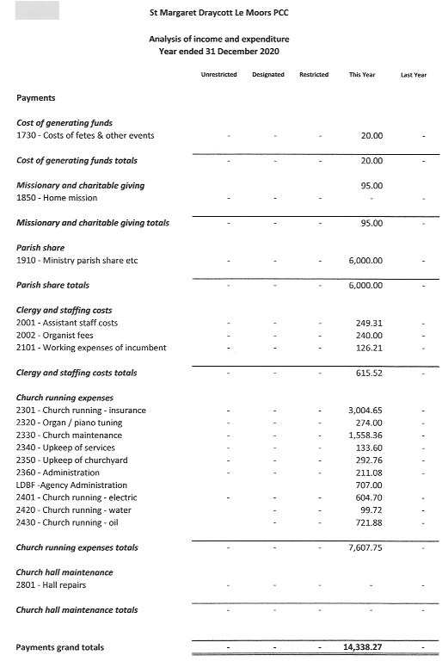
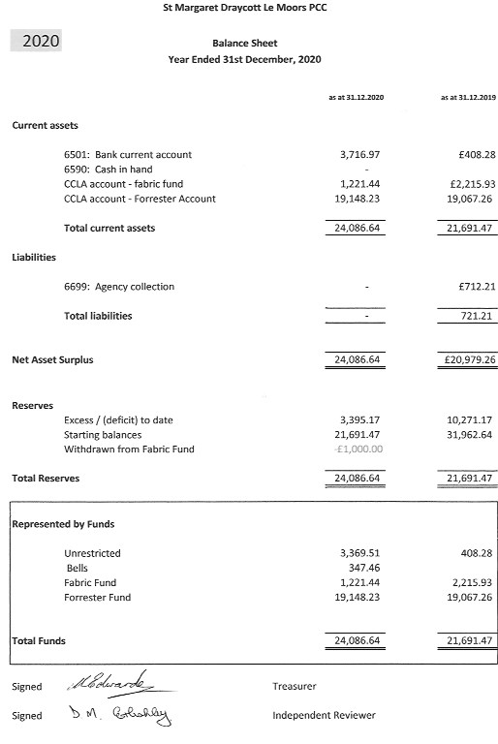
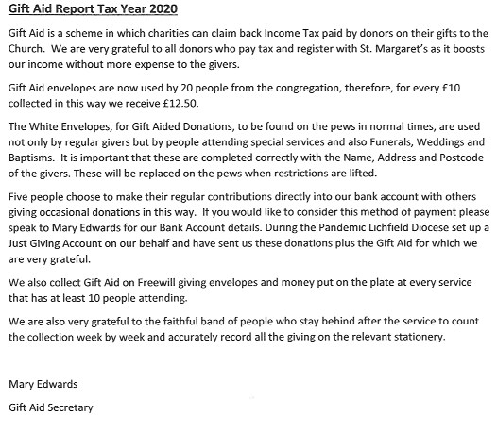
6. Report on the fabric of St. Margaret's January to December 2020.
Much has been written and will continue to be written of the effects of the Covid19 pandemic. It has had a significant effect on the life of St. Margaret’s Church.

The first PCC meeting of 2020 was on Monday 20th January, and the fabric of the church was in good order.

Throughout 2020, the wardens with the assistance of the Rector implemented the Government rules and Church of England House of Bishops directives regarding Covid19.
Regular checks were made on the building and the heating system was kept on throughout the winter months.

Whenever services were allowed, entry into the building followed the prescribed rules regarding Covid19 Risk Assessments, track and trace, social distancing, hand sanitation and cleaning the building.

The risk assessment on the bell tower has been received and work has started on the recommendations.

With the overseeing procedures the bells have been rung on several occasions - in support of the NHS, on VE day etc.

Sadly, there has been no opportunity for the Harvest Festival, Memorial, Remembrance Day, Carol, Crib services to take place.

The wardens would like to take this opportunity to thank all those people who have assisted during 2020 by following the Covid19 rules, regarding services and work carried out in and around the church.

In the absence of any other nominations, we are prepared to serve another 12 months period however should we be appointed, this next period 2021/2022, would be our 6th successive year in post after which, under the Church Representation Rules 2020, we are obliged to stand down. In the event no-one comes forward for the year 2022/2023, a resolution must be passed this year to allow either of us to serve beyond 2022. We understand that any resolution would not commit the Rector or us to being wardens, but the authority would be in place should the situation arise.
- J. Fletcher. J. H. Meller.

7. Draycott Church Hall Report 2020
At the beginning of 2020 we had nine groups meeting regularly in the Church Hall enjoying their diverse activities and the companionship which ensued. We also hosted parties, elections and regular Church Meetings.
On 16th March, 2020 all this ended when the hall was closed by the Pandemic Covid-19 and it has remained closed ever since.
We look forward to welcoming these and other groups back to the hall when the crisis has ended.
All this can only happen because of the small band of volunteers who regularly give up their time to clean the hall, tend the grounds and generally keep the hall in good repair, thus keeping down the costs. On the administrative side they also book the hall keeping in touch with the leaders of the groups and look after the finances, keeping good accounts to present to the Benefice and Diocese at the end of the year.
Our grateful thanks go these dedicated people who would love to be joined by others to help spread the load – is that YOU.
Mary Edwards.
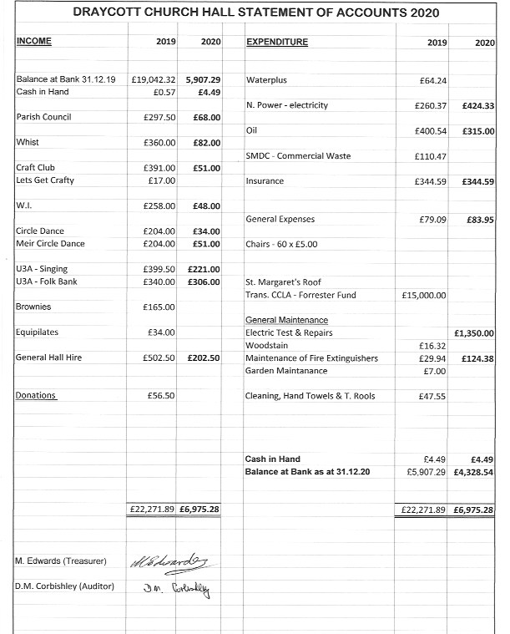

8. Deanery Synod Report 2020.
Our thanks to St Peter’s synod representatives for allowing us to publish their Deanery Synod Report 2020, it commences:
“I thought it worth taking a moment to step back and look at the structure of our church hierarchy.
We are St. Peter’s and St. Margaret’s church, in Forsbrook Parish and Draycott Parish respectively and collectively known as the Benefice of Forsbrook and Draycott.
Our benefice sits in a bigger group of benefices called Cheadle Deanery, which consists of 14 churches in 5 benefices, see Deanery image.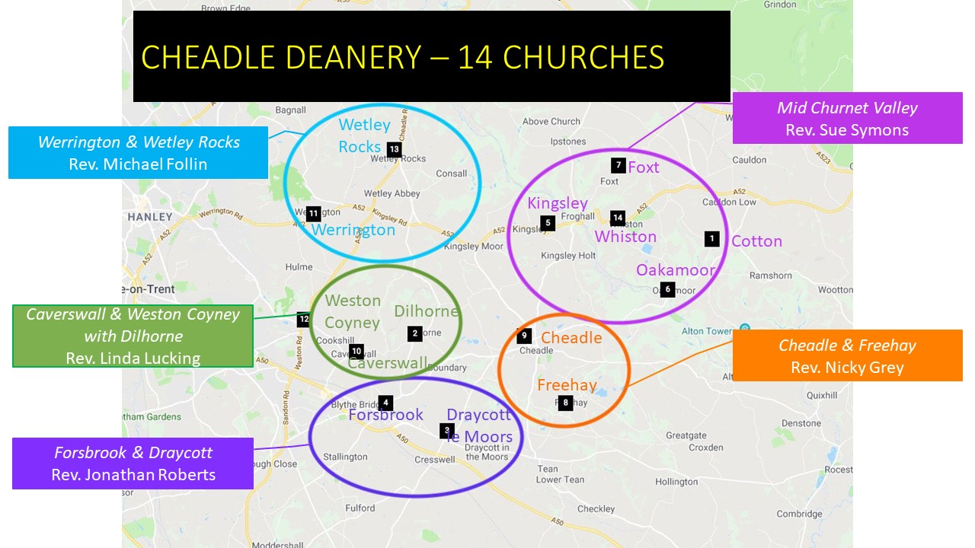
Our Cheadle Deanery sits within the Archdeaconry of Stoke on Trent,
(10 Deaneries).
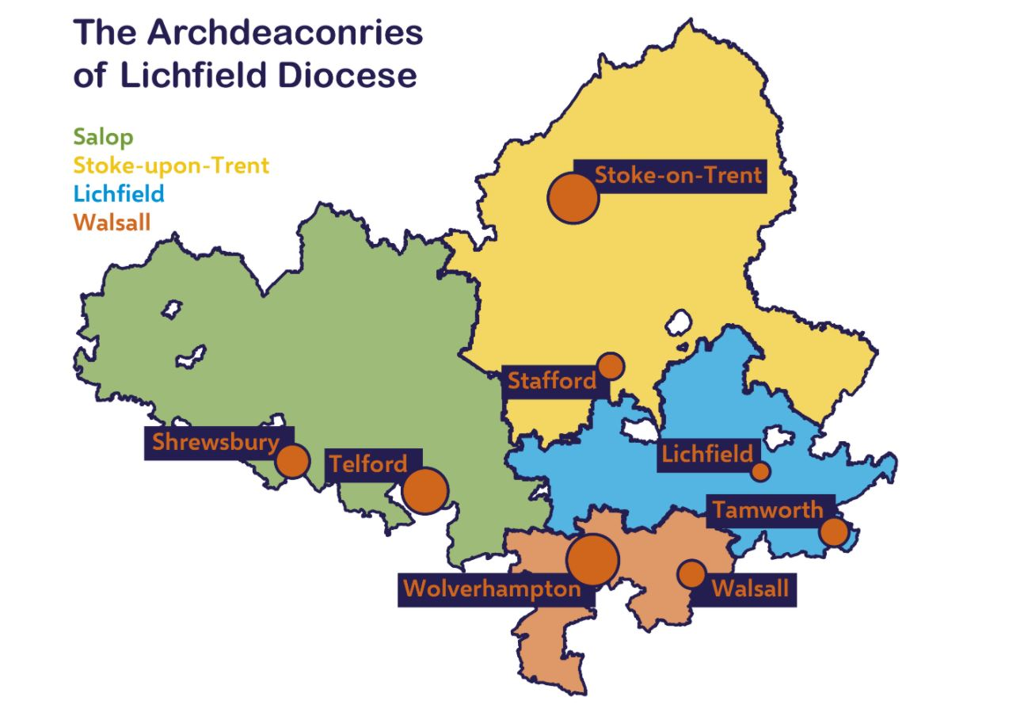
This Archdeaconry of Stoke on Trent sits in the Diocese of Lichfield.
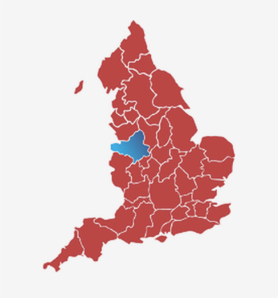
The word Synod means an assembly of clergy and sometimes laity in a diocese or other division of a church.
Report.
Cheadle Deanery synod met on 1 occasion in 2020 at St. Mildred’s Church Whiston for a Deanery quiz which was attended by 30 people, then again more formally on the 10th March 2021 via Zoom.
A new Deanery Secretary, Kate Bradshaw, was nominated and appointed.
The position of lay chairperson, Sylvia Bainbridge, was renewed. There was a continuing request from the Diocese that all Deaneries continue to report on the same three categories of Discipleship, Vocation and Evangelism. Reporting on the challenges and opportunities in each of these categories.
Each of the 5 benefices within Cheadle Deanery reported on each of these categories.
It transpires that there is great apprehension at the anticipated high numbers of weddings, baptisms and memorial services which have been massively disrupted by current World events.
The Diocese has a new project called Shaping for Mission which was discussed by our Deanery Shaping for Mission spokesperson Kate Bradshaw.
This project is designed to assist us all within the Diocese and Deanery to better share our resources, skills and ideas. A particularly significant and nicely timed idea considering the effects of the pandemic.
The Diocese has a target that by the year 2030 all churches, church halls and clergy buildings will be net zero carbon emissions, this includes all heating, lighting and energy.”

Laura Hulse, Ruth Dirkin, Archie Archibald, (St Peter’s Deanery Synod Reps).
****************************
St Margaret’s Deanery Synod Representatives are:
Kate Bradshaw, Jane Meller and David Meller.

9. ST. MARGARET’S BELL RINGERS ANNUAL STATEMENT OF ACCOUNTS 2020.
RECEIPTS
Balance as at 31st December 2019 £256.47
EXPENDITURE in the year 2020 Nil

Balance as at 31.12.20 £256.47
S. Edwards.

